**Bank Loan Analytics**

**1. Loan Applications**

1.1 Total Loan Applications

select COUNT(id) as total_loan_applications

from bank_loan_data;



Counts all id values in bank_loan_data to get the **total number of loan applications**.

1.2 MTD Loan Applications

select COUNT(id) as MTD_total_applications

from bank_loan_data

where MONTH(issue_date) = 12;



Counts all applications (id) where the loan issue_date falls in **December**, giving the **MTD (Month-to-Date) total applications**.

1.3 PMTD Loan Application

select COUNT(id) as PMTD_total_applications

from bank_loan_data

where MONTH(issue_date) = 11;



Counts all applications (id) with issue_date in **November**, giving the **previous month’s total applications**.

**2. Funded Amount**

2.1 Total Funded Amount

select sum(loan_amount) as total_funded_amount

from bank_loan_data;



Sums all loan_amount values to get the **total amount funded across all loans**.

2.2 MTD Total Funded Amount

select sum(loan_amount) as MTD_total_funded_amount

from bank_loan_data

where MONTH(issue_date) = 12;



Calculates the **total funded loan amount in December** by summing loan_amount where issue_date is in month 12.

2.3 PMTD Total Funded Amount

select sum(loan_amount) as PMTD_total_funded_amount

from bank_loan_data

where MONTH(issue_date) = 11;



Calculates the **total funded loan amount in November** by summing loan_amount where issue_date is in month 11.

**3. Amount Received**

3.1 Total Amount Received

select sum(total_payment) as total_amount_received

from bank_loan_data;



Sums all total_payment values to get the **total amount repaid by borrowers**.

3.2 MTD Total Amount Received

select sum(total_payment) as MTD_total_amount_received

from bank_loan_data

where MONTH(issue_date) = 12;



Sums total_payment for loans issued in **December** to get the **MTD total amount received**.

3.3 PMTD Total Amount Received

select sum(total_payment) as PMTD_total_amount_received

from bank_loan_data

where MONTH(issue_date) = 11;



Sums total_payment for loans issued in **November** to get the **PMTD total amount received**.

4. Interest Rate

4.1 Average Interest Rate

select round(avg(int_rate) * 100, 2) as avg_int_rate

from bank_loan_data;



Calculates the **average loan interest rate** by taking the mean of int_rate and converting it to a percentage.

4.2 MTD Average Interest Rate

select round(avg(int_rate) * 100, 2) as MTD_avg_int_rate

from bank_loan_data

where MONTH(issue_date) = 12;



Calculates the **average interest rate for loans issued in December**, expressed as a percentage.

4.3 PMTD Average Interest Rate

select round(avg(int_rate) * 100, 2) as PMTD_avg_int_rate

from bank_loan_data

where MONTH(issue_date) = 11;



Calculates the **average interest rate** for loans issued in **November**, multiplied by 100 to show as a percentage.

5. DTI

5.1 Average DTI

select round(avg(dti)*100, 2) as avg_dti

from bank_loan_data;



Calculates the **average debt-to-income ratio** across all loans and multiplies by 100 to express it as a percentage.

5.2 MTD Average DTI

select round(avg(dti)*100, 2) as MTD_avg_dti

from bank_loan_data

where MONTH(issue_date) = 12;



Calculates the **average debt-to-income ratio** for loans issued in **December**, expressed as a percentage.

5.3 PMTD Average DTI

select round(avg(dti)*100, 2) as PMTD_avg_dti

from bank_loan_data

where MONTH(issue_date) = 11;



Finds the **average debt-to-income ratio** for loans issued in **November**, multiplying by 100 to show it as a percentage.

**6. Good Loan Issued**

6.1 Good Loan Percentage

select

cast((count(case

when loan_status = 'Fully Paid' or loan_status = 'Current' then id

end) * 100.0) / count(id) as decimal(10,2)) as good_loan_percentage

from bank_loan_data;



Calculates the **percentage of good loans** by dividing the number of loans with status 'Fully Paid' or 'Current' by the total loan count, then multiplying by 100.

6.2 Good Loan Applications

select count(id) as good_loan_applications

from bank_loan_data

where loan_status = 'Fully Paid' or loan_status = 'Current';



Counts all loan applications where the status is 'Fully Paid' or 'Current', representing the **total number of good loans**.

6.3 Good Loan Funded Amount

select sum(loan_amount) as good_loan_funded_amount

from bank_loan_data

where loan_status = 'Fully Paid' or loan_status = 'Current';



Sums the loan_amount for loans with status 'Fully Paid' or 'Current' to get the **total funded amount of good loans**.

6.4 Good Loan Amount Received

select sum(total_payment) as good_loan_amount_received

from bank_loan_data

where loan_status = 'Fully Paid' or loan_status = 'Current';



Sums total_payment for loans with status 'Fully Paid' or 'Current' to get the **total amount received from good loans**.

**7. Bad Loan Issued**

7.1 Bad Loan Percentage

select

(count(case

when loan_status = 'Charged Off' then id

end) * 100.0) / count(id) as bad_loan_percentage

from bank_loan_data;



Calculates the **percentage of bad loans** by dividing the number of 'Charged Off' loans by total loans, then multiplying by 100.

7.2 Bad Loan Applications

select count(id) as bad_loan_applications

from bank_loan_data

where loan_status = 'Charged Off';



Counts all loan applications with status 'Charged Off', representing the **total number of bad loans**.

7.3 Bad Loan Funded Amount

select sum(loan_amount) as bad_loan_funded_amount

from bank_loan_data

where loan_status = 'Charged Off';



Sums the loan_amount of all 'Charged Off' loans to get the **total funded amount for bad loans**.

7.4 Bad Loan Amount Received

select sum(total_payment) as bad_loan_amount_received

from bank_loan_data

where loan_status = 'Charged Off';



Sums total_payment for all 'Charged Off' loans to get the **total amount received from bad loans**.

**8. Loan Status**

select

loan_status,

count(id) as loan_count,

sum(total_payment) as total_amount_received,

sum(loan_amount) as total_funded_amount,

avg(int_rate * 100) as int_rate,

avg(dti * 100) as dti

from bank_loan_data

group by loan_status;

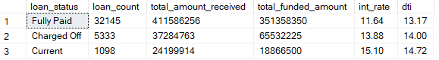

Summarizes each **loan status** with the total loans, total payments received, total funded amount, average interest rate, and average DTI.

select

loan_status,

SUM(total_payment) as MTD_total_amount_received,

SUM(loan_amount) as MTD_total_funded_amount

from bank_loan_data

where MONTH(issue_date) = 12

group by loan_status;

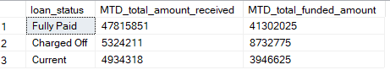

Summarizes **December loans** by status, showing the total amount received and total funded amount.

**B. Bank Loan Report | Overview**

1. Month

select

MONTH(issue_date) as month_number,

DATENAME(MONTH, issue_date) as month_name,

COUNT(id) as total_loan_applications,

SUM(loan_amount) as total_funded_amount,

SUM(total_payment) as total_amount_received

from bank_loan_data

group by MONTH(issue_date), DATENAME(month, issue_date)

order by month(issue_date);

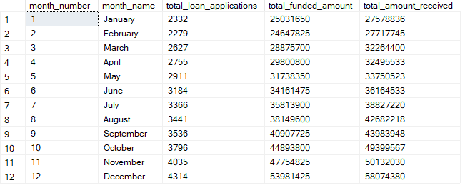

Provides a **monthly breakdown** of loan applications, funded amounts, and payments received, ordered by month.

2. State

select address_state as state,

count(id) as total_loan_applications,

sum(loan_amount) as total_funded_amount,

sum(total_payment) as total_amount_received

from bank_loan_data

group by address_state

order by address_state;

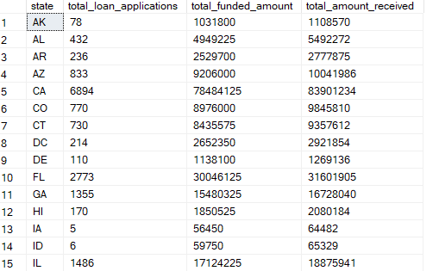

Summarizes loans by **state**, showing total applications, funded amounts, and payments received.

3. Term

select term,

count(id) as total_loan_applications,

sum(loan_amount) as total_funded_amount,

sum(total_payment) as total_amount_received

from bank_loan_data

group by term

order by term;



Summarizes loans by **term length**, showing total applications, funded amounts, and payments received.

4. Employee length

SELECT emp_length AS employee_Length,

COUNT(id) AS total_Loan_Applications,

SUM(loan_amount) AS total_Funded_Amount,

SUM(total_payment) AS total_Amount_Received

FROM bank_loan_data

GROUP BY emp_length

ORDER BY emp_length

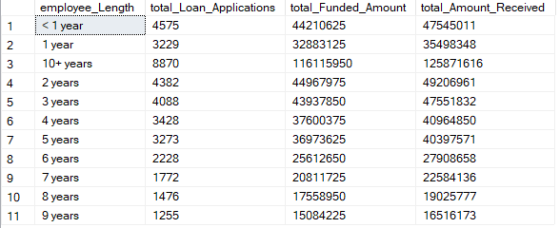

Summarizes loans by **borrower’s employment length**, showing total applications, funded amounts, and payments received.

5. Purpose

SELECT purpose,

COUNT(id) AS total_loan_applications,

SUM(loan_amount) AS total_funded_amount,

SUM(total_payment) AS total_amount_received

FROM bank_loan_data

GROUP BY purpose

ORDER BY purpose

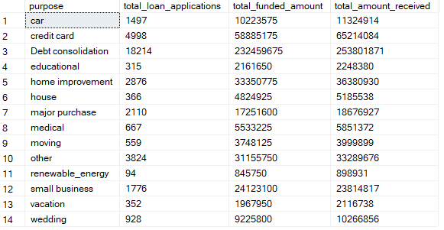

Summarizes loans by **purpose**, showing total applications, funded amounts, and payments received.

6. Home Ownership

SELECT home_ownership AS home_ownership,

COUNT(id) AS total_loan_applications,

SUM(loan_amount) AS total_funded_amount,

SUM(total_payment) AS total_amount_received

FROM bank_loan_data

GROUP BY home_ownership

ORDER BY home_ownership

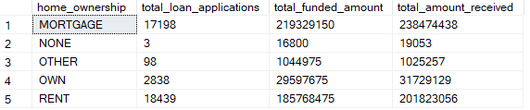

Summarizes loans by **home ownership status**, showing total applications, funded amounts, and payments received.